MAZEN FACTORY DATA ANALYSIS REPORT

In this project, we will be analysing eCommerce Database for Mazen factory, an online retailer.

OBJECTIVES:

* Access and explore the Maven Fuzzy Factory database
* To analyze and optimize marketing channels, measure and test website conversion performance, and use data to understand the impact of new product launches

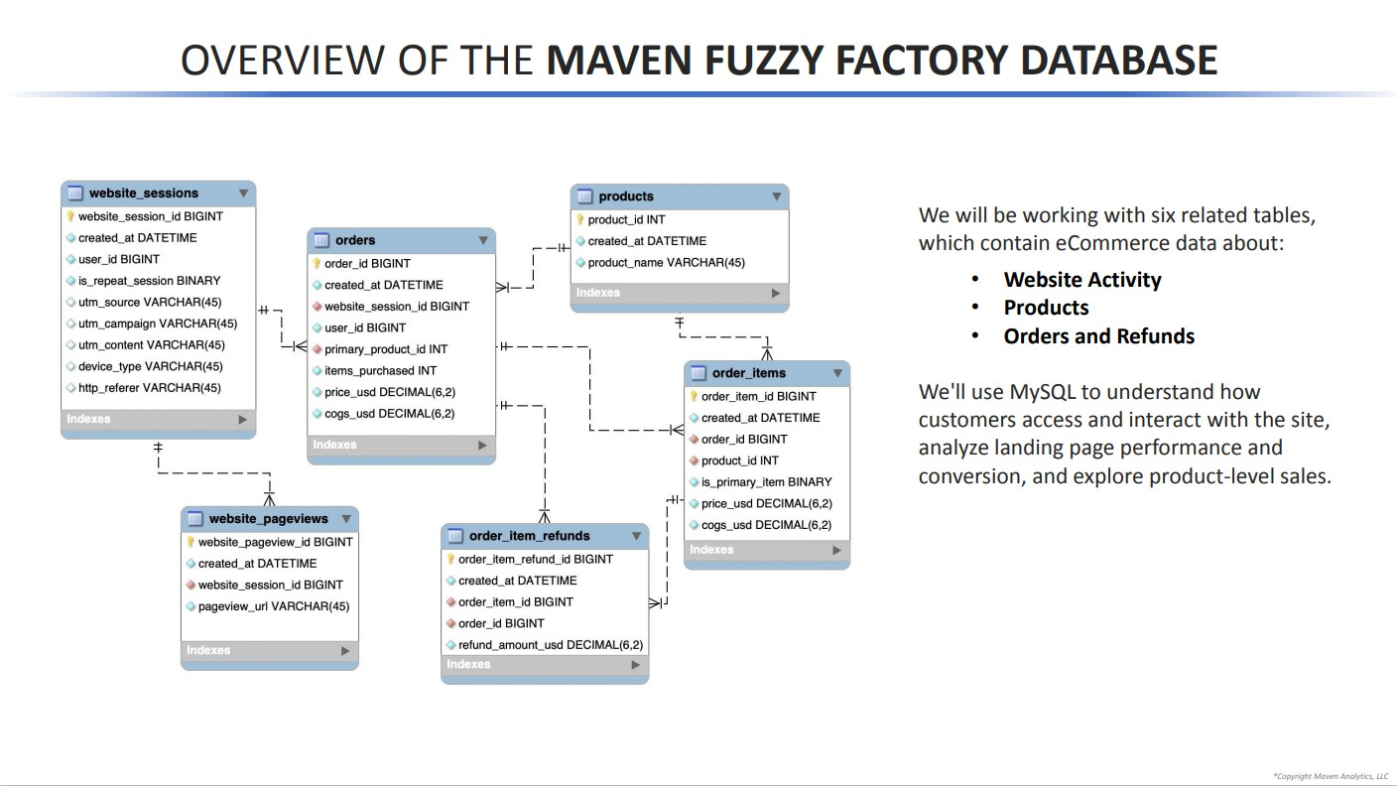OVERVIEW OF THE DATABASE:

FINAL INSIGHTS

Since our company has been running for **3 years now**, we need to learn about our volume growth. We will **pull overall session and order volume**, trended by quarter for the life of the business.

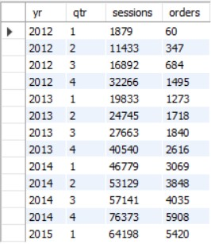

We see a tremendous growth in sessions (**1879 to 64198 per quaters**) and orders (**60 to 5420 per quarters**) owing to our bid optimization, introducing new products and pages, etc.

* Analysing quarterly figures since we launched, for session-to-order **conversion rate, revenue per order**, and revenue per session **to gauge efficiency.**

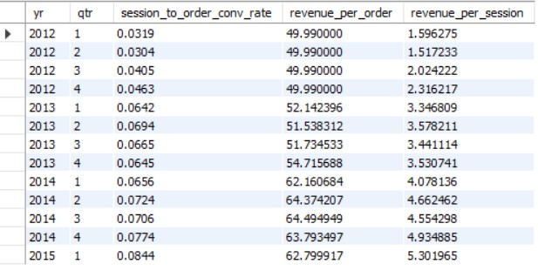

The Quaterly sessions to order conv. Rate **increases 2.5x from 3.2% to 8.4% and revenue per order from $50 to $62 (~25% increase).**

* Now we should look upon specific channels and pull a quarterly view of orders from Gsearch nonbrand, Bsearch nonbrand, brand search overall, organic search, and direct type-in.

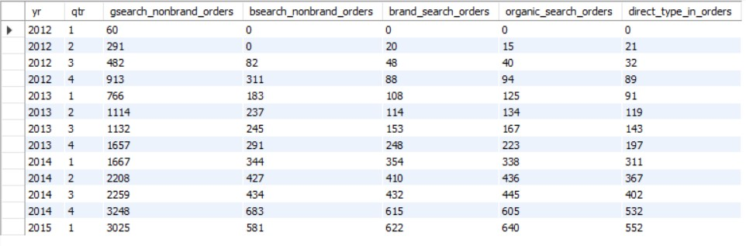

Oveall all brand and non-brand sessions grew well, but due to higher bidding we did on **Gsearch we saw exponential increase(60 to 3025 per quarters)** in this channel.

* 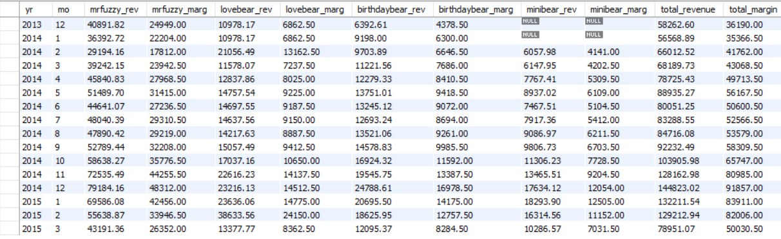The company has come a long way since the days of selling a single product. We should pull **monthly trending for revenue and margin by product**, along with total sales and revenue and check for seasonality.
* The total **revenue increased to $1,29,212 (43x)** and total margin to **$ 82,006 (46x)** from $3000 and $1830 (2012) respectively intially.
* While **mr.fuzzy’s revenue increased 18x in 3 years**, **love_bear’s revenue increased by 13x in just 2 years**, similarly adding other products highly aided to total revenue.
* This implies that the **new products out performed orignal** and provided additional profits to company.
* 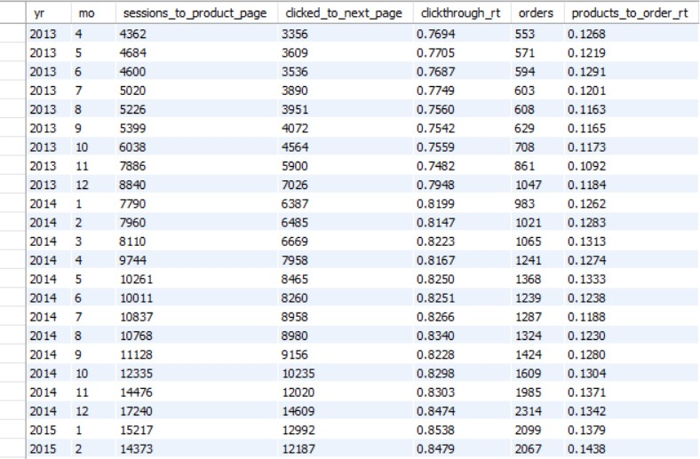Let’s dive deeper into the impact of introducing new products. We pull **monthly sessions to the /products page**, and show how the % of those sessions **clicking through another page has changed over time**, along with a view of **how conversion from /products to placing an order** has improved.
* The sessions to product page conversion saw improvement from **743 to 14373(19x)**, implies efficiency of conversion funnel.
* The **click through rates improved from 71% to 85%** implies that consumers are satisfied with new changes we brought on our billing, product pages,etc.
* Since we added few new products, we should look how well each product **cross-sells from one another**.

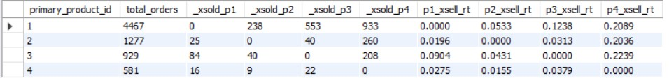

* We see that product **4 goes quite well along with all other products**[ with 1 (21% selling rate), 2 (20% selling rate), 3 (23% selling rate), implies we can keep it in recommendation list. Also prod. 3 performs good with product 1 (12% selling rate).

DETAILED ANALYSIS

TRAFFIC SOURCES ANALYSIS

We will start by **analysing Traffic sources** (Traffic source analysis is about understanding where your customers are coming from and which channels are driving the highest quality traffic)

* **Finding top traffic sources** breakdown by UTM source, campaign and referring domain.

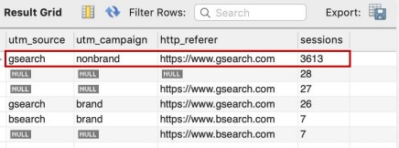

Looks like Gsearch-nonbrand sessions are of great concern.

* Now we will calculate the **conversion rate (CVR)** from session to orders to get overall effiiciency.

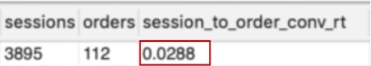

Low CVR found, in next step we will work on **bid optimization** to understand the value of various segments of paid traffic and improve budget allocation.

* Bid Optimization based on Gsearch **device-level performance**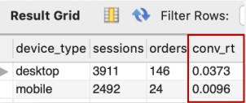

Learning that desktop performs better, we bid more on it, next we will find out **time-series trend** after applying higher bid on desktop

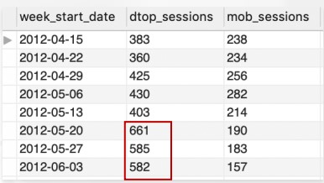

Looks like higher bid resulted in increased website sessions for desktop.

ANALYSING WEBSITE PERFORMANCE

We will observe **most-viewed website pages**, ranked by session volume.

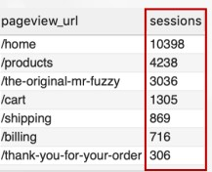

It Seems like the homepage, the products page, and the Mr. Fuzzy page get the bulk of our traffic.

* We will now perform **landing page analysis** to understand the performance of our key landing pages and then testing to improve your results.

We calculate bounce rate for HOME landing page.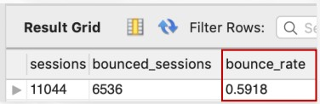

Almost a 60% bounce rate! Quite high for paid search

* Then, We ran a **new custom landing page (/lander-1) in a 50/50 test** against the homepage (/home) for our gsearch nonbrand traffic. Pulling bounce rates for the two groups.

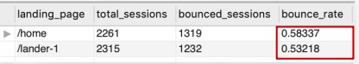

Looks like the custom lander has a lower bounce rate (improvement).

* Now we will test new page for longer time period by pulling our overall paid search **bounce rate trend weekly**.

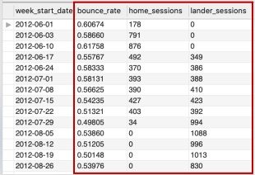

We shifted to new custom page and bounce rate dropped significantly.

* Performing **Conversion funnel analysis** to understand and optimize each step of our user’s experience on their journey toward purchasing our products.

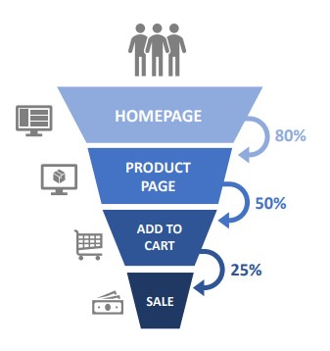

* To learn how many customers drop off and **how many continue on at each step** and calculating **click_through rates.**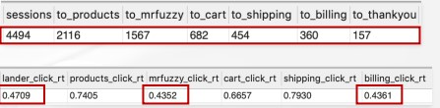

Looks like we should focus on the lander, Mr. Fuzzy page, and the billing page, which have the lowest click rates.

* We tested an **updated billing page** based on your funnel analysis. Now we look and see whether /billing-2 is doing any better than the original /billing page by calculating **billing to order conversion rate.**

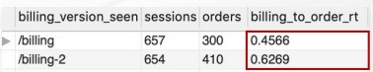

Looks like the new version of the billing page is doing a much better job converting customers.

ANALYSIS FOR CHANNEL MANAGEMENT

PAID MARKETING CAMPAIGNS: TRACKING PARAMETERS (REVIEW)

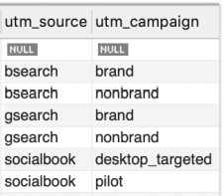(Paid traffic is commonly tagged with tracking (UTM) parameters, which are appended to URLs and allow us to tie website activity back to specific traffic sources and campaigns)

Various utm parameters in our data

* Weekly trended session volume to **compare gsearch v/s bsearch** sources.

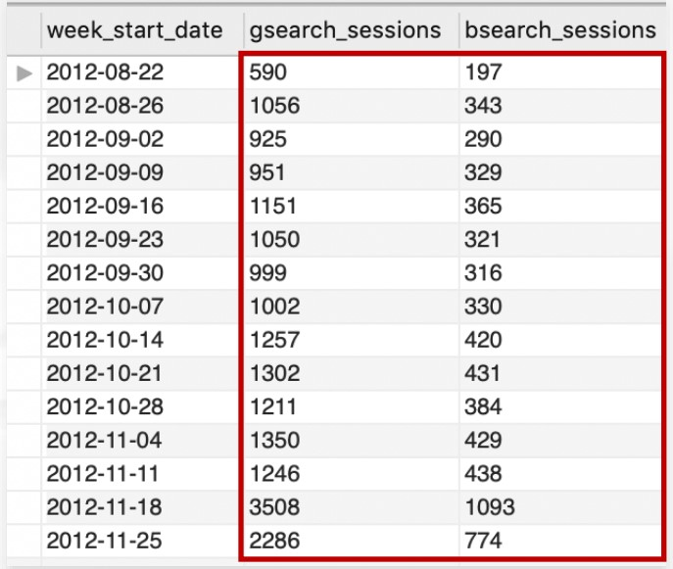

It looks like bsearch tends to get roughly a third the traffic of gsearch (This is big enough that we should really get to know the channel better)

* To analyse deeply, pulling nonbrand conversion rates from session to order for gsearch and bsearch, and slicing the data by device type.

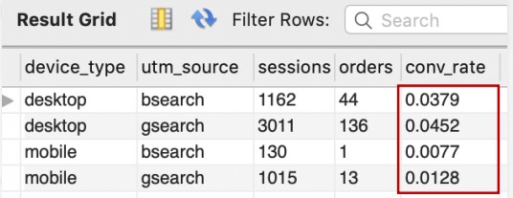

The channels don’t perform identically, so we should differentiate our bids in order to optimize our overall paid marketing budget.

* bidding down bsearch based on its under-performance. Pulling out **weekly session volume for gsearch and bsearch nonbrand**, broken down by device, also calculating a **comparison metric** to show bsearch as a percent of gsearch for each device.

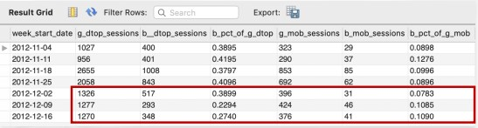

Looks like bsearch traffic dropped off a bit after the bid down.

* Analyzing our branded or direct traffic to keeping a pulse on how well our brand is doing with consumers, and how well your brand drives business.
* Pulling organic search, direct type in, and paid brand search sessions by month as %of non-brand sessions.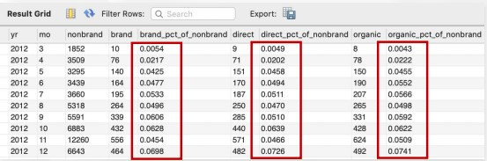

Looks like not only are our brand, direct, and organic volumes growing, but they are growing as a percentage of our paid traffic volume.

BUSINESS PATTERNS & SEASONALITY

* As we continue to grow, we should take a look at 2012’s monthly and weekly volume patterns, to see if we can find **any seasonal trends** we should plan for in 2013.

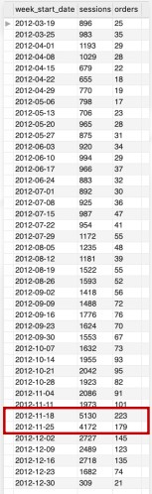Looks like we grew fairly steadily all year, and saw **significant volume around the holiday months** (especially the weeks of Black Friday and Cyber Monday [November Month]).

* Now company is considering adding live chat support to the website to improve our customer experience. We need to **analyze the average website session volume, by hour of day and by day week**, so that we can staff appropriately.

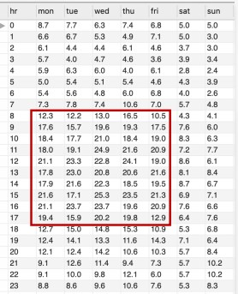

Looks like 8 am to 5 pm have peak session rate. We can plan on one support staff around the clock and then we should double up to two staff members from 8am to 5pm Monday through Friday.

PRODUCT ANALYSIS

* Analyzing product sales helps you understand how each product contributes to your business, and how product launches impact the overall portfolio
* To analyze sales performance at a product level, we will look at our order data, and tie in the specific product(s) driving sales
* For our **current flagship product**, analyse monthly trends to date for **number of sales, total revenue, and total margin generated** for the business

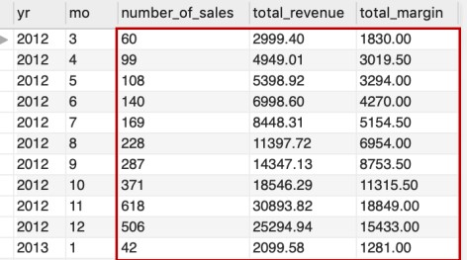

Good growth pattern in general. This will serve as great baseline data so that we can see how our revenue and margin evolve as we roll out the new product.

* We launched our second product (2013). Now we should analyse **monthly order volume, overall conversion rates, revenue per session, and a breakdown of sales by product.** 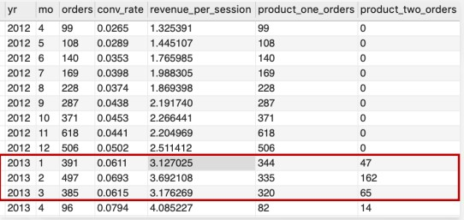

This confirms that our conversion rate and revenue per session are improving over time, which is great.

* Still its hard to understand if the growth since January 2013 is due to our new product launch or just a continuation of our overall business improvements.
* Thus, we will look at **clickthrough rates from /products since the new product launch** on January 6th 2013, by product, and **compare to the 3 months** leading up to launch as a baseline.

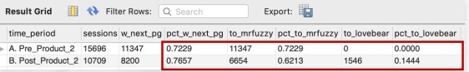

Looks like the percent of /products pageviews that clicked to Mr. Fuzzy has gone down since the launch of the Love Bear, but the overall clickthrough rate has gone up, so it seems to be generating additional product interest overall.

* As a follow up, we should probably look at the **conversion funnels for each product individually.**

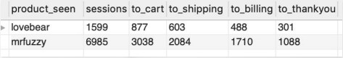

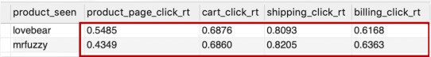

We had found that adding a second product increased overall CTR from the /products page, and this analysis shows that the Love Bear has a better click rate to the /cart page and comparable rates throughout the rest of the funnel.

* Now we will look for **cross selling products** (products users are most likely to purchase together, and offering smart product recommendations).
* Company started giving customers the **option to add a 2nd product while on the /cart page.**
* We compare the **month before vs the month after the change**? I’d like to see **CTR from the /cart page, Avg Products per Order, AOV, and overall revenue per /cart page view.**

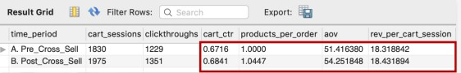

Looks like our products per order, AOV, and revenue per /cart session are all up slightly since the cross-sell feature was added. Doesn’t look like a game changer, but the trend looks positive.

* On December 12th 2013, company launched a third product targeting the birthday gift market (Birthday Bear).
* We are to do pre-post analysis comparing the **month before vs. the month after, in terms of session-to-order conversion rate, AOV, products** per order, and **revenue per session.**

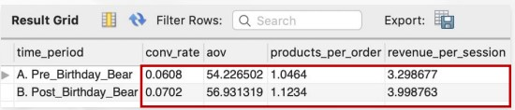

It looks like all of our **critical metrics have improved** since we launched the third product.

* Now we will focus on **Product Refund Analysis** controlling for quality and understanding where you might have problems to address.
* According to reports, Mr. Fuzzy supplier had some quality issues, as a result, we replaced them with a new supplier on September, 2014.
* **Pull monthly product refund rates, by product, and confirm our quality issues are now fixed.**

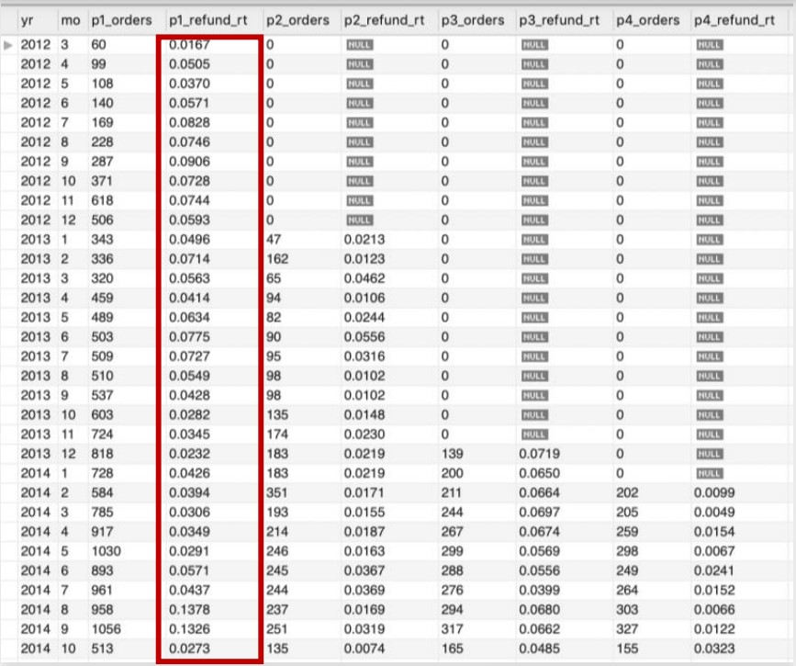

Looks like the refund rates for Mr. Fuzzy did go down after the initial improvements, new supplier is doing better.

USER ANALYSIS

* To understand user behavior and identify some of your most valuable customers.
* If customers have repeat sessions, they may be more valuable than we thought. We need to pull data on **how many of our website visitors come back for another session**

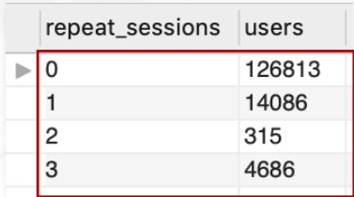

Looks like a fair number of our customers (15%) do come back to our site after the first session.

* To better understand the behavior of these repeat customers. Could you help me understand the **minimum, maximum, and average time between the first and second session** for customers who do come back

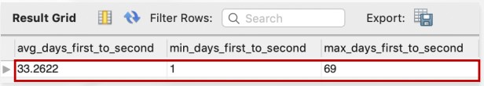

Interesting to see that our repeat visitors are coming back about a month later, on average.

* Now we need to understand the channels they come back. Curious if it’s all direct type-in, or if we’re paying for these customers with paid search ads multiple times.
* We will be **Comparing new vs. repeat sessions by channel**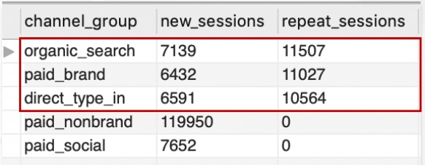

So, it looks like when customers come back for repeat visits, they come mainly through organic search, direct type-in, and paid brand. Only about 1/3 come through a paid channel, and brand clicks are cheaper than nonbrand.

* To get better insights, we can also make **comparison of conversion rates and revenue per session for repeat sessions vs new sessions**.

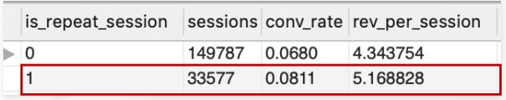

Looks like repeat sessions are more likely to convert, and produce more revenue per session. Since we aren’t paying much for repeat sessions, we should probably take them into account when bidding on paid traffic.